How to Get Into Bain's Sophomore Programs
Meta description: WSG founder Stephen Turban breaks down Bain's sophomore programs: BEL, CREW, First Forward and Consulting Kickstart, one application, and the ACI path.

A sophomore I worked with last fall, call her Maya, called me on a Sunday night with two deadlines in the same week. One was a bank's sophomore program, a real internship with a video interview due that Friday. The other was the application for one of Bain's early programs. She'd found it that morning by typing "Bain sophomore programs" into Google, and it closed on Thursday. Her question was the one I get every November: which one matters more?

I'm Stephen Turban. I went through McKinsey's recruiting myself and now run WSG, where some version of Maya's call comes in every fall. My answer surprised her: stop ranking them, because they aren't the same kind of thing. The bank program was an internship pipeline with interviews attached. Bain's was a day and a half in February with no interview attached, and an application she could finish in two evenings. She did both. She spent a February weekend at CREW, the Associate Consultant Intern application she sent that spring had two Bain names in it from that weekend, and she signed her ACI offer that summer.

This guide covers what Bain's sophomore programs actually are for the 2027 cycle, with every detail checked against bain.com on October 5, 2026: who qualifies, the single application that closes November 30, what Bain is screening for, what the programs do and don't lead to, and how to use the few weeks between a February program and the ACI deadline that follows it.

What sophomore programs does Bain offer?
Bain runs three in-person sophomore programs in the US and Canada, BEL, CREW and First Forward, plus a virtual series called Consulting Kickstart, and all three in-person programs share one application that closes November 30, 2026 [VERIFY: Bain's exploratory programs page]. Bain lists all three on one undergraduate exploratory programs page. Each in-person program is a day and a half in a Bain office in late January or February 2027, built around one of Bain's affinity groups (the firm's employee communities, like Women at Bain), with travel paid by the firm. None of them is a paid internship: the real Bain internship for your class is the Associate Consultant Intern role, which you apply for in spring 2027 for Summer 2028.

Does Bain have a sophomore internship?
Bain has no sophomore summer internship in the United States. Its 10-week programs are the Associate Consultant Internship for students with one summer left before graduation, the Summer Associate role for MBA students, and SkillBridge for service members [VERIFY: Bain's internships and programs page]. Prep sites that call BEL "Bain's sophomore internship" are describing the week-long version of the program that ran through 2025; the 2027 version is a day and a half. So a sophomore's first Bain summer is the junior summer, and the way in is the ACI application you'll submit as a sophomore.

What Bain wants from its sophomore programs
Start on the firm's side of the table. Bain fills its junior-summer ACI class about fifteen months ahead. For Summer 2027 seats, the two US deadlines fell on March 29 and August 31, 2026, both for students graduating by June 2028 [VERIFY: Bain ACI page and school pages]. If that pattern holds, the first look Bain gets at your class is an application in spring 2027, from sophomores the firm has mostly never met.

A day and a half in January or February fixes that. Bain's sophomore programs exist so that recruiters and affinity groups have names and faces from your class a few weeks before the ACI applications land. Bain says this almost directly about Consulting Kickstart, which it calls "intentionally designed to help you build a strong foundation for future Bain recruiting processes." The in-person programs have the same job with a smaller group.

The second job is a wider pool. Each program is built around an affinity group: Black at Bain and Familia at Bain for BEL, Women at Bain for CREW, First at Bain for First Forward. Bain's eligibility wording has loosened over the years. In 2023, a UCLA posting described BEL as being for students who identify as Black, Hispanic or Indigenous [VERIFY: UCLA math department posting, January 2023]. The 2027 page says BEL is open to "all second-year (sophomore) students" who "have an interest in connecting with" those two groups. First Forward is still defined by background, and Bain is specific about what it means: first in your family to finish a four-year degree, or growing up in a lower-income household, either one.

The third job is the one most applicants miss, and it comes from the firm's founding. Bill Bain was a group vice president at BCG in the early 1970s and grew tired of writing a report and moving on. He described feeling like "a consultant on a desert island, writing a report, putting it in a bottle, throwing it in the water, then going on to the next one." He left in 1973 and built a firm that signs long relationships and stays to help clients carry out the plan [VERIFY: Wikipedia, Bain & Company history]. A firm like that needs people who work in the same team, on the same client, for years. That is where the operating principle Bain still publishes comes from: "A Bainie never lets another Bainie fail." It's the title of an episode of the firm's own Beyond the Bio podcast. Bain's programs are heavy on mentors and small groups because team fit is the thing the firm is actually screening for, and it starts screening for it in a sophomore's application.

Back-derive the competitive applicant from those three jobs. Academics that will clear the ACI screen in a year. One leadership story with a number in it. A reason for Bain that's about the work or the people you've met, not a ranking. And, because the selection step is a recorded video, the ability to say all of that to a camera in about a minute.

Building Entrepreneurial Leaders (BEL)
BEL is the longest-running of the three, and the one most prep sites get wrong.

What it is. A 1.5-day, in-person program in a Bain office on February 4 and 5, 2027 [VERIFY: dates on Bain's BEL page]. Bain's BEL page lists interactive sessions, case discussions, professional development workshops, small-group workshops, networking and social events with members of the Black at Bain and Familia at Bain affinity groups, and time in the office itself.

Who it's for. Second-year students finishing a four-year degree in the United States or Canada by winter 2028 or spring 2029 who have an interest in connecting with those two groups [VERIFY: eligibility wording]. Non-US and non-Canadian citizens can apply if they attend a US or Canadian school. You have to be in the US or Canada on the program dates, because Bain pays domestic travel and not international travel.

Where. Fourteen offices: Atlanta, Austin, Boston, Chicago, Dallas, Denver, Houston, Los Angeles, Montreal, New York, San Francisco, Seattle, Toronto and Washington, DC. Two consolidations are on the page: if your first choice is Denver, Los Angeles or Seattle, you attend in Los Angeles, and Montreal or Toronto first choices attend in Toronto [VERIFY: office list and hosting notes].

The application. One form covers BEL, CREW and First Forward. It opens in mid-October and closes November 30, 2026 at 11:59 pm Pacific [VERIFY: Bain's BEL page]. You pick up to three office preferences and submit a resume, an optional cover letter, your education details, an unofficial transcript and test scores if you have them. After the deadline, Bain sends video prompts through HireVue. There are no interviews. You can mark interest in one, two or all three programs, but if you're selected you attend one.

What it leads to. Bain's current page doesn't promise anything past the program itself. It says you'll leave "with a clearer understanding" of career paths, and its FAQ says the program is highly selective and that unsuccessful applicants should "stay in touch and apply for the Associate Consultant Internship." Read that as it's written. A 2027 BEL seat is a head start on relationships and a line on your resume, not a guaranteed interview.

The history matters, because it's why the prep sites disagree with Bain's own page. BEL used to be a week-long externship that fed straight into case interviews, and Bain's own site is full of people who came in that way. Cristina Gutierrez Ramos, now a practice manager in Bain's Chicago office, writes on her Bain profile that she started "the summer after my sophomore year through a five-day externship program called BEL" (an externship is a short shadowing program, not a paid internship). Sofia Cordovez Capriles, a University of Virginia engineering student, describes on Bain's careers blog how she got in. She applied to BEL in the 2025 cycle, which "started with a round of case interviews." She spent a full week in the DC office in May 2025 and did a final round of two longer cases the week after. In summer 2026 she was an ACI in Washington, building a store-density map for an auto glass client out of raw data [VERIFY: Bain careers blog, August 28, 2026]. That is the version Management Consulted and Duke's career center still describe: a five-day program in the summer, a deadline in February.

The 2027 version is shorter, earlier and interview-free. Nothing on Bain's site says why, and I won't guess. What I'd take from the change: the program moved to the weeks right before the ACI window, and the selection step moved from a case interview to a camera. Plan for the version on the page today, not the one your club's seniors went through.

CREW: Connecting and Resourcing Empowered Women
CREW is BEL's sibling, built around the Women at Bain affinity group, and it runs two weeks later.

What it is. The same shape, on Bain's CREW page: 1.5 days in person, February 18 and 19, 2027, with interactive sessions, case discussions, workshops and social events, and the explicit promise that you'll "hear firsthand from members of our Women at Bain affinity group about how they've built thriving careers at Bain" [VERIFY: dates and wording on Bain's CREW page].

Who it's for. Bain's page uses the same eligibility sentence as BEL: second-year students finishing a four-year degree in the US or Canada by winter 2028 or spring 2029 who have an interest in connecting with Women at Bain [VERIFY: eligibility wording]. Earlier cycles, and university career pages like Duke's, describe CREW as a program for sophomore women, and that is who it serves. The 2027 wording is about interest in the group rather than a stated identity requirement, so read the live page and apply if it describes you.

Where. The same fourteen offices as BEL, with one difference in the consolidation: Denver, Los Angeles and Seattle first choices attend in Seattle, and Montreal and Toronto first choices attend in Toronto [VERIFY: hosting notes].

The application and what it leads to. Same form, same November 30 deadline, same HireVue step, same "no formal interviews" line, same FAQ answer about applying to ACI if you're not selected. CREW and BEL are the same product aimed at two different affinity groups, so pick the one whose community you'd actually want to spend a weekend with, and say why in the application.

Maya's weekend at CREW came down to three things she could use later: two associate consultants whose names went into her ACI cover letter, a case discussion that showed her what a Bain-style "so what" sounds like out loud, and the recruiter who told her, in person, when the ACI window would open. None of those is an interview. A CREW weekend is worth two names for the cover letter, a model of the Bain answer, and a recruiter who gives you the ACI dates in person, and all three belong in the spring application.

First Forward
First Forward is the one of the three defined by background rather than by interest in a group.

What it is. A 1.5-day, in-person program on January 28 and 29, 2027, across Bain's US offices, built around First at Bain, the firm's first-generation and low-income affinity group [VERIFY: dates on Bain's First Forward page]. The description on Bain's First Forward page is the plainest of the three: "You don't need any prior business experience; just an openness to learn, a willingness to grow, and an interest in discovering what's possible with the right support and community behind you."

Who it's for. Second-year students finishing a four-year degree in the US or Canada by winter 2028 or spring 2029 who are the first in their family to attend college, or who identify with growing up in a lower socioeconomic household [VERIFY: eligibility wording]. Bain's FAQ is explicit that you don't need to be both: it defines first generation as being the first in your family to get a four-year degree, and low income as identifying with the experience of growing up in a lower-income household. Non-US and non-Canadian citizens at US or Canadian schools can apply.

Where. US offices only. The page lists Atlanta, Austin, Boston, Chicago, Dallas, Denver, Houston, Los Angeles, Minneapolis, New York, San Francisco, Seattle, Silicon Valley and Washington, DC, with Los Angeles, Denver and Seattle first choices hosted in Denver [VERIFY: office list and hosting note]. No Montreal or Toronto.

The application and what it leads to. Same single form, same November 30 deadline, same HireVue prompts, same no-interview FAQ, same answer about ACI. First Forward is the right box to check if either definition fits you, and it's the only one of the three where your background, not your stated interest, is the eligibility test.

One practical note. First Forward lands in the first two weeks of most spring semesters, so a selected student should warn professors in the first week back. Bain books the travel, and you'll miss a day of classes.

Consulting Kickstart
Kickstart is the one program on this list you can't apply to by the time this article ranks, and it's still worth understanding.

What it is. A three-part virtual webinar series in October, described on Bain's Consulting Kickstart page, where sophomores hear from recruiters and from consultants who recently went through Bain's process, and get questions answered about the firm [VERIFY: Bain's Consulting Kickstart page]. No office visit, no case, no interview. Consulting Kickstart is a free virtual series, and Bain says in its own words that it exists to set sophomores up for the firm's later recruiting steps. The line on Bain's page is the clearest statement of purpose on any of these pages: it is "intentionally designed to help you build a strong foundation for future Bain recruiting processes."

Who it's for. Second-year students at four-year universities in the US or Canada. No affinity-group framing and no background requirement.

The deadline. Applications for the fall 2026 series closed Monday, October 5, 2026 at 11:59 pm Pacific [VERIFY: Bain's Kickstart page; Penn Career Services and WashU posted the same deadline in September]. The registration form asks for your top three office preferences, and Bain suggests picking them by where you might want to live after college.

What changed. Kickstart's audience and timing have changed from one year to the next, so a freshman should check Bain's page each September instead of assuming this year's shape. Duke's career center listed the 2025 version as a program for first-year students with an April 15 deadline [VERIFY: Duke career hub, August 2025]. The 2026 version is for sophomores in the fall. If you're a freshman reading this, assume a fall 2027 series for your class and check Bain's page in September [VERIFY: 2027 Kickstart timing].

Why it still matters if you missed it. The three in-person programs ask for office preferences, and Kickstart is where Bain walks sophomores through what makes each office different. If you missed it, your school's Bain page and two coffee chats do the same job before November 30.

The Bain programs that aren't for sophomores
Four other names show up on Bain's programs page and in Google results, and none of them is yours. BASE, ADvantage and ExperienceBain are MBA and advanced-degree programs, and no US sophomore program called "Bain Build" exists.

- BASE (Building and Supporting Excellence) is for pre-MBA students. Bain founded it in 2019 around a week-long BASE Camp in US offices, and the 2026 program is closed with 2027 details promised in the spring [VERIFY: Bain's BASE page].
- ADvantage is a one-week program for PhDs, postdocs, MDs, JDs and residents, with four days on a real case team and consideration for a full-time consultant role afterward.
- ExperienceBain is a virtual summer program for incoming first-year MBA students at a list of named schools.
- "Bain Build" doesn't exist as a US sophomore program. The only "Build at Bain" on the firm's site is an AI masterclass for students in South America [VERIFY: Bain's programs page]. Older prep guides that name a "Bain Build" sophomore program are wrong.

Every Bain program a US sophomore can apply to is one of four: BEL, CREW, First Forward or Consulting Kickstart. If a program name you've heard isn't on that list, it's for someone else or it doesn't exist.

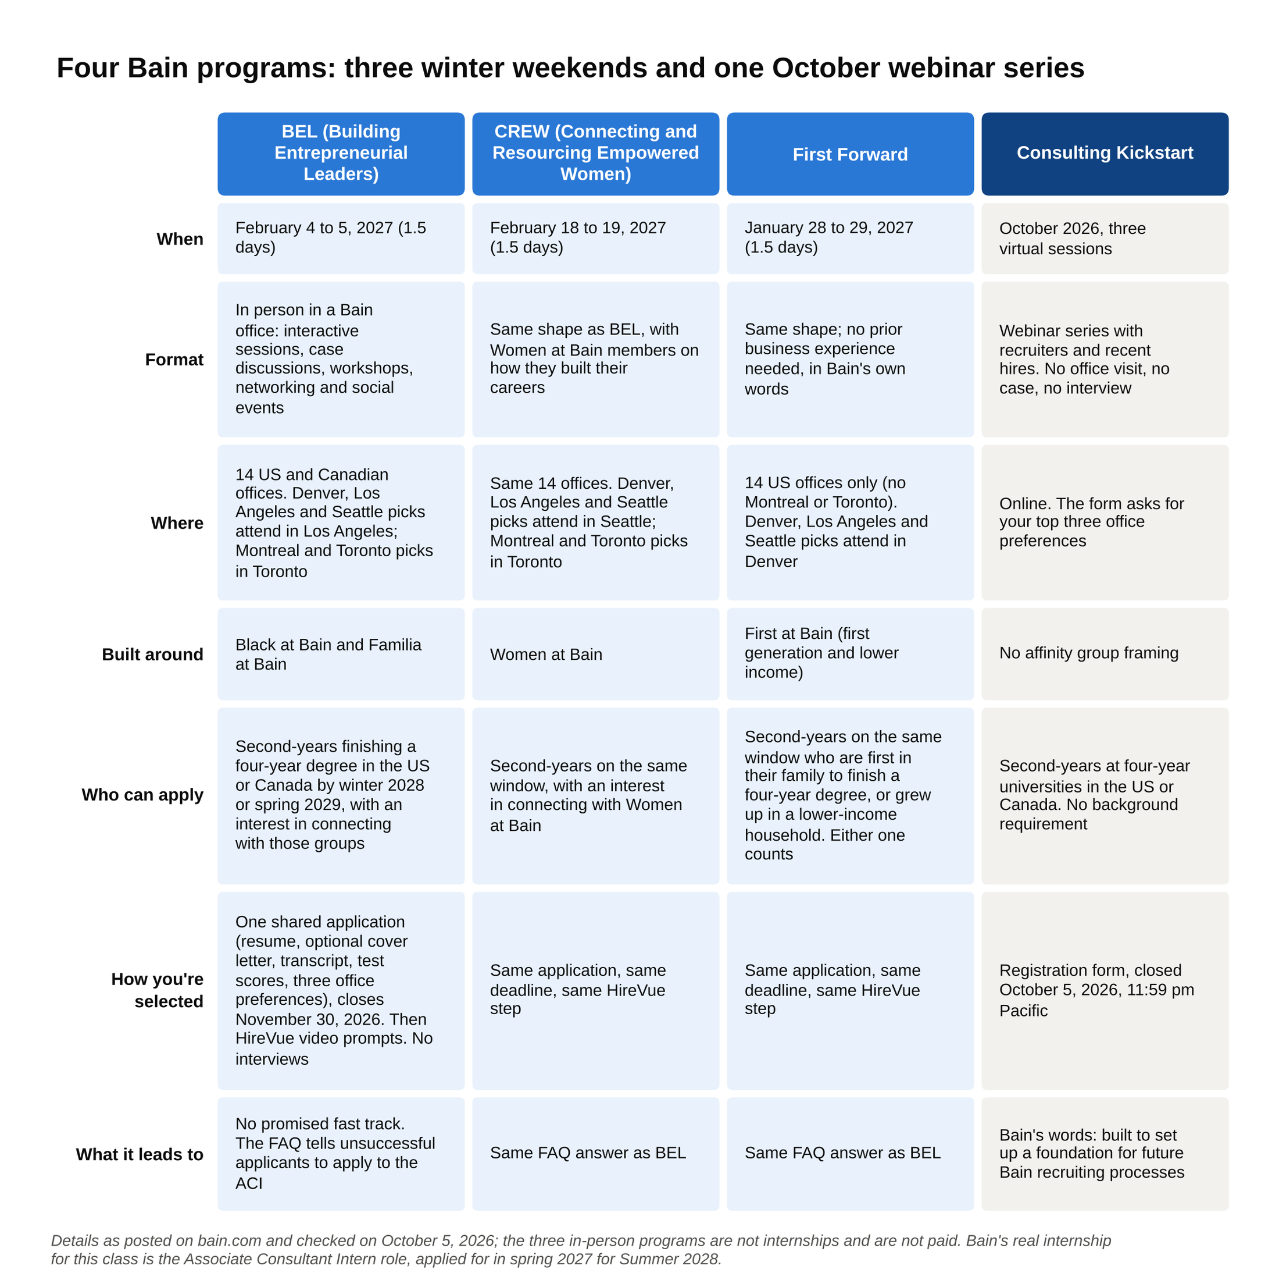
BEL, CREW and First Forward are the same day and a half aimed at three communities with one application, and Kickstart is the free webinar series that already closed.

The Bain sophomore programs timeline for the Class of 2029
Here's the whole cycle for a sophomore reading this in October 2026, graduating around spring 2029, in one table.

Step | When | What happens | Status on October 5, 2026
Consulting Kickstart (virtual, three sessions) | Register by October 5, 2026; sessions in October | Webinars with recruiters and recent hires | Closes October 5, 2026 [VERIFY: Bain's Kickstart page]
BEL, CREW and First Forward application (one form) | Opens mid-October, closes November 30, 2026, 11:59 pm Pacific | Resume, optional cover letter, transcript, test scores, three office preferences | Posted; portal not yet open [VERIFY: Bain's exploratory programs page]
HireVue video prompts | After November 30 | Recorded answers; no live interview | Timing not published [VERIFY: invitation timing]
First Forward | January 28 to 29, 2027 | 1.5 days in a US office | Dates posted
BEL | February 4 to 5, 2027 | 1.5 days in a US or Canadian office | Dates posted
CREW | February 18 to 19, 2027 | 1.5 days in a US or Canadian office | Dates posted
Associate Consultant Intern, Summer 2028 | Expected to open in spring 2027; last cycle's first deadline was March 29 | Digital assessment, then two rounds of case interviews | Not posted; school pages say applications "typically open in the spring" [VERIFY: Summer 2028 ACI dates]
ACI summer | Summer 2028 | 10 weeks on a case team, $9,000 a month in the US | [VERIFY: pay on Bain's ACI page]
Full-time Associate Consultant | Offer decision at the end of the internship, start after graduation in 2029

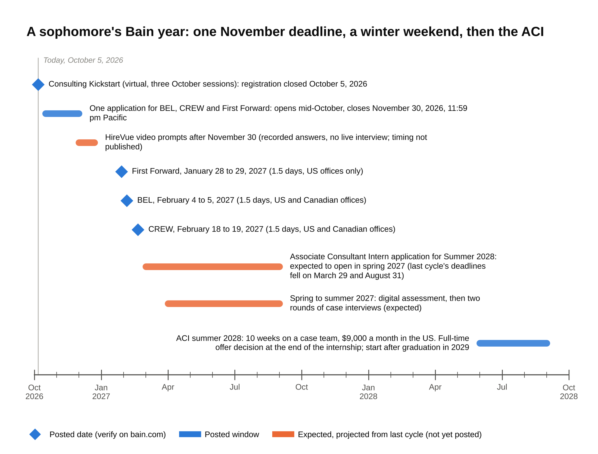
The only firm deadline in front of a sophomore today is November 30, and the ACI window that matters is expected a few weeks after the February programs.

Two things jump out of that table. The gap between a February program and the first ACI deadline is weeks, not months, so case practice has to start before the program, not after it. The only Bain step with a firm deadline in front of a sophomore right now is the November 30, 2026 application. For the three-firm calendar, our consulting recruiting timeline lays MBB deadlines side by side.

What Bain screens for, and how to write each piece
Bain hasn't published a rubric for these programs. What it has published is the list of what you submit, and each piece answers one question a screener is asking.

The transcript answers: will this person clear the ACI screen in a year? Bain doesn't publish a GPA floor. The effective bar I see for MBB interviews at target schools is around 3.7, and higher for a non-target applicant without another signal [VERIFY: founder's pattern, not a published figure]. A sophomore has three semesters on the transcript, so one weak semester is survivable if the trend is up and the hard courses are on there. Don't drop a quantitative course to protect the number. A screener reads the course list too.

Test scores answer the same question when the transcript is thin. Bain says "if applicable," so they're optional. Include an SAT or ACT if it helps you. Leave it off if it doesn't. Nobody is penalized for a blank optional field.

The resume answers: has this person led something, and can they count? One page, and every leadership line carries a result with a number. The consulting resume format we use covers the layout screeners expect. The edit that matters most at the sophomore stage is the one Maya made on her second draft:

- Before: "Treasurer, Women in Business. Managed the club budget and organized events."
- After: "Treasurer, Women in Business (120 members). Rebuilt the budget after a $3,000 shortfall, cut event costs 25 percent by switching venues, and funded a second speaker series."

Same job, same semester. The second version tells a reader what was wrong, what she did, and what it was worth.

The office preferences answer: where will this person actually work? You pick up to three, and Bain says to choose based on where you'd want to live and work after graduation. Your preferences also decide which offices read your file and where you'd attend. Pick one office you have a real reason for, and make the other two places you'd move to. Don't list Boston, New York and San Francisco because they sound serious. If you grew up in Texas and want to go home, say Dallas, Austin and Houston. The program is partly a recruiting tool for the office, and an applicant who'd actually move there is worth more to Dallas than one who's treating it as a backup.

The optional cover letter answers: has this person talked to anyone at Bain? Write it, and keep it under 300 words. It's the only place on the form where a conversation shows up in writing. A paragraph that works:

I'm applying to CREW because of a conversation with an associate consultant in your Chicago office in September. She described a three-week due diligence for a private equity client where her job was to figure out whether a retailer's store growth plan was believable before the client paid for it. The part that stuck with me was that the answer was a number and a risk, not a slide deck. That is the kind of problem I want to learn to solve, and the Women at Bain members I've met are the people I'd want to learn it from.

Notice what that paragraph has: a real conversation, a specific piece of work, a reason tied to the affinity group the program is built around. Notice what it doesn't have: "prestigious," "culture," or a sentence about how long you've dreamed of consulting.

The HireVue prompts answer: can this person talk? Bain doesn't publish the prompts, the prep time or the retake rule [VERIFY: HireVue details, from the invitation email]. From what sophomores report, expect three or four questions in the family of why consulting, why Bain, which program and why, and a leadership story. Each answer should run 60 to 90 seconds, start with the answer, and carry one specific. Here's a sample for "Why consulting, and why Bain?":

Last spring I ran the budget for our campus food co-op, and the problem that interested me wasn't the budget. It was why Tuesday sales ran about 40 percent below Thursday's. I pulled two years of register data, found the Tuesday gap matched a schedule change in the business school, and we moved our hot-food hours. Sales rose about 15 percent over the semester. That's the kind of problem I want to spend my first years working on: a real operation, a number that's wrong, and a fix someone has to actually run. Bain is first on my list because of that last part. I worked through Bain's FashionCo practice case and then asked an associate consultant in the Chicago office how real retail work compares. She described a diligence where her team's job was to test whether a growth plan held up before anyone paid for it, and that's the work I want to learn.

Ninety seconds, said at a normal pace. Answer first, one story with two numbers, one named piece of Bain's own material, one conversation.

All of the pieces are read together, and the screener's question across them is whether this sophomore will be a strong ACI applicant in fifteen months. A clean transcript with a generic resume loses to a 3.6 with a leadership story that has a dollar figure in it.

The HireVue step, and how it differs from the ACI case interview
Bain's sophomore programs have no live interview, and the selection step is a set of recorded video answers submitted after the November 30 deadline. Bain's FAQ says it plainly for all three programs: "There will be no formal interviews." Here is what that step looks like and how to prepare for it, since most sophomores have never recorded one.

HireVue is a recording platform. You log in, a question appears on screen, you get a short window to think, and then the camera records your answer. The recording goes to Bain's reviewers. Bain hasn't published how many prompts there are, how long the think-time is, or whether you can re-record [VERIFY: details in Bain's HireVue invitation]. Several banks use the same tool for their own screens, so if you've recorded one for a bank, you know the mechanics.

Three things make a recorded answer land:

- Lead with the answer. "I'm applying to First Forward because I'm the first in my family to go to college and I want to meet people who did this before me." Then the story. A reviewer who watches dozens of recordings in an afternoon decides in the first sentence whether to keep listening.
- One specific per answer. A number, a named conversation, a piece of Bain's own material. Two is fine. Five is a list.
- Practice on camera, not in your head. Record yourself on your laptop answering the four likely prompts, watch it with the sound off, and fix whatever you'd notice in someone else: looking at your own face instead of the lens, speaking faster than you'd speak across a table, trailing off at the end. Then record it again with the sound on and cut anything past 90 seconds.

Now the contrast. The ACI process you'll go through in spring 2027 is a different test with different machinery: a digital assessment, then two rounds of live case interviews. The assessment is a 30 to 40 minute online test, Sova or TestGorilla depending on your office, that Bain says is "one part of the review process" [VERIFY: Bain's digital assessment page]. Then two rounds of case interviews, where an interviewer hands you a business problem, usually framed the way Bain's private equity clients frame theirs, and watches you structure it, work the numbers out loud, and give an answer with a number and a risk attached. If you've never seen one, our guide to what a case interview is walks through the format from zero.

So the sophomore program selects on who you are and how you talk. The ACI selects on how you structure and solve a business problem in a 40-minute case. Doing well on the first proves nothing about the second, and a program seat in February isn't a reason to delay case practice. If anything it's the opposite, because the people you'll meet at the program will ask whether you've started casing, and "yes, since December" is a better answer than "I'm planning to."

What Bain sophomore programs lead to, and the weeks between
Bain's 2027 program pages don't promise a fast track to an ACI interview, and you should plan as if they don't. The FAQ on all three pages says the same thing: the programs are highly selective, and if you're not selected, apply to the ACI. Nothing says that if you are selected, you skip a step. Earlier cohorts did get a direct path, because BEL used to include case interviews before and after a full week in the office. The 2027 programs have no interview in them. Ask the recruiter at your program, in person, exactly how the program connects to the ACI process for your office, and write down the answer [VERIFY: whether 2027 participants receive any ACI fast track; confirm with your recruiter].

What the programs do give you, and what to do with each:

- Names. Two or three associate consultants and a recruiter who will remember you. Within 24 hours of leaving, send each a short note with one specific thing from the weekend, and ask one question that keeps the thread open. Those names go into your ACI cover letter in March.
- The Bain version of "so what." The case discussions are short, but they show you how a Bain consultant moves from a chart to a sentence a client can act on. Write down two examples before you leave the office.
- The office. You'll know whether you'd actually want to work there, which makes the office preference on your ACI application a real choice instead of a guess.
- A line on the resume. "Bain & Company, Building Entrepreneurial Leaders participant, February 2027" is a line other firms' screeners recognize.

Then the calendar, because the gap is short. If Bain's ACI window follows the 2026 pattern, the first deadline lands in late March 2027, about seven weeks after BEL and five after CREW [VERIFY: Summer 2028 ACI dates]. Here is the plan I gave Maya, moved forward a year:

- October to November 2026. Resume to one page with a number on every leadership line. Three offices chosen for real reasons. Cover letter drafted after two coffee chats. Submit the single application before Thanksgiving, not on November 30. Record your four practice HireVue answers the week you submit.
- December 2026. Whatever the program decision, start live cases with a partner from your consulting club: two a week, one profitability and one market sizing, and ten minutes of mental math a day. Read Bain's two published practice cases, Coffee Shop Co. and FashionCo, on its case interview page and write your own "better answer" for each before reading Bain's.
- January to February 2027. Program weekend if you got one, thank-you notes within a day, three cases a week either way. Draft the ACI cover letter with the names from the weekend.
- March 2027. The week before you submit the ACI application, do Sova's sample questions once untimed and once timed. Submit in the first window. Industry reporting puts most MBB interview slots in the first deadline rather than the second [VERIFY: first-window share], and Bain's own two-window structure in 2026 means a second chance exists but is smaller.
- Spring to summer 2027. Assessment, first round, final round. If you get the offer, you intern in Summer 2028 on a case team at $9,000 a month, and Bain's ACI page says a successful summer "may lead to invitation for interviews or even an offer" for the full-time Associate Consultant role [VERIFY: pay and wording on Bain's ACI page].

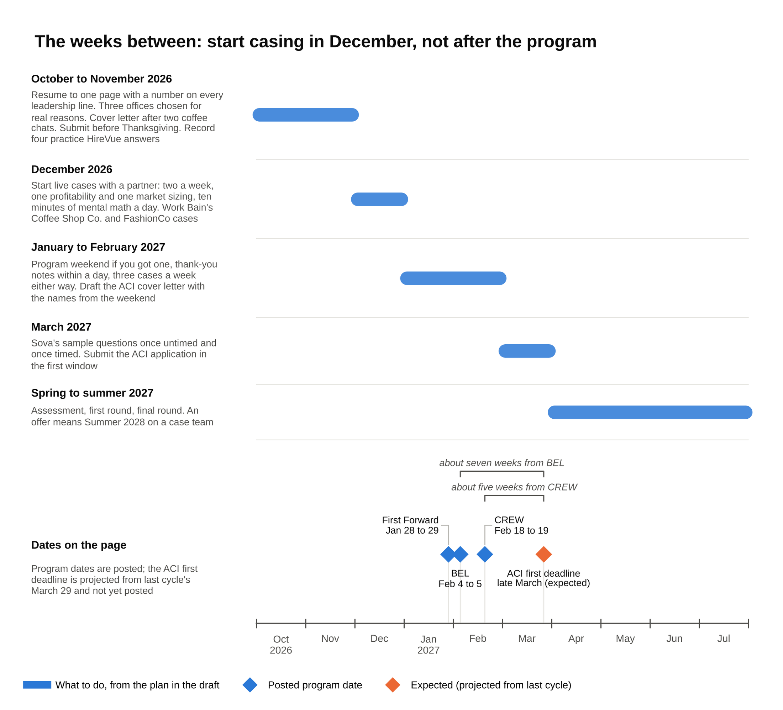
Five to eight weeks separate an early 2027 program from the expected ACI deadline, so the December cases are the ones that count.

The sophomore program and the ACI application are five to eight weeks apart, so the program is where you collect names and the December before it is where you learn to case. Students who wait for the program decision before starting cases lose the month that matters most.

If you don't get in
Missing a Bain sophomore program costs you a weekend in February and nothing else, because the ACI application in spring 2027 is open to every sophomore and it's the step Bain actually hires from. Bain says as much in every FAQ. Here is what else to put on the calendar.

- The ACI itself. Apply in the first window in spring 2027. Everything above about names and casing applies with or without a program seat. The only difference is that your cover letter names people from coffee chats instead of from a program.
- BCG Embark and the Summer Associate application. BCG's visible sophomore track is Embark, a virtual conference inside BCG Launch that ran May 14, 2026 with registration by April 15 [VERIFY: 2027 Embark dates], and its junior-summer Summer Associate application also now lands in sophomore spring. Growing Future Leaders, BCG's older sophomore internship, had no live posting as of late September 2026 [VERIFY: GFL status]. Our BCG sophomore internship guide covers all of it.
- McKinsey Sophomore Summer Business Analyst (SSBA). A roughly 10-week paid internship in the sophomore summer, the one true sophomore internship at MBB. Recent cycles took applications in the summer and early fall of sophomore year, eligibility wording has changed year to year, and McKinsey has skipped a cycle before, so read the posting on McKinsey's own site rather than a tracker [VERIFY: Summer 2027 SSBA posting and deadline].
- Bank sophomore programs. These are the thing Maya was weighing against Bain, and they're real internship pipelines with interviews and pay. Our list of sophomore insight programs for IB has the current cycle's deadlines and eligibility.
- Tier 2 and boutique consulting. Oliver Wyman, L.E.K., Kearney and the healthcare boutiques run junior-summer internships on later, often rolling, timelines, and a strong one puts you in a good spot for Bain's full-time Associate Consultant round in fall 2028 [VERIFY: full-time AC timing for the Class of 2029; the Class of 2027 deadline on Bain's school pages is October 11, 2026]. Our 15 consulting internships for undergraduates covers which open when.

And the fall of sophomore year itself, which is the part no program replaces. Open your school's Bain page and find the recruiter's name. Book two coffee chats with associate consultants, one in your first-choice office. Join your consulting club's case program. Two coffee chats and three practice cases by Thanksgiving put a sophomore ahead of most students who got a program seat and waited until February to start.

Say this, don't say that at the sophomore stage
These are for the HireVue prompts, the optional cover letter, and the coffee chats before November 30. The same answers, tightened, work in the ACI process in the spring. A strong sophomore answer names one conversation or one piece of Bain's own work, and never leans on a ranking.

Why Bain?

Don't say: "Bain is number one on Glassdoor and everyone says the culture is the best of the three."

Say: "I talked to an associate consultant in your Dallas office who described a diligence where her team had three weeks to decide whether a growth plan was believable. The answer was a number and a risk. I want to learn to do that, and I want to do it at the firm that stays to help the client carry out the plan."

On the Glassdoor line: Bain was number one on Glassdoor's Best Places to Work list in 2025, which the firm's own press release called a record seventh time, and eighth on the 2026 list [VERIFY: Glassdoor and Bain press release, January 2025 and January 2026]. Recruiters hear that fact ten times a day. It's true, and it's useless in an answer, because it tells them nothing about you.

Why consulting?

Don't say: "I want to solve complex problems across a variety of industries and work with smart people."

Say: "I spent last semester figuring out why our co-op's Tuesday sales ran 40 percent below Thursday's, and the fix was a schedule change that raised sales 15 percent. I want to spend my first years on problems like that, with a team, for companies where the answer actually gets used."

Which program, and why?

Don't say: "I'm interested in all three programs because they would all be great opportunities to learn about Bain."

Say: "First Forward. I'm the first in my family to go to college, and the person I most want to meet is someone who sat where I'm sitting and is now three years into the job. I've marked BEL too because I'd want to connect with Familia at Bain, but First Forward is the one I'd pick."

Which office, and why?

Don't say: "New York, Boston and San Francisco, because they're the biggest offices."

Say: "Dallas first, because I grew up outside Fort Worth and I'd move back. Austin and Houston second and third for the same reason. I've talked to one AC in Dallas, and I'd rather be in a smaller office where I know the people than a big one where I'm a name on a list."

Tell me about a time you led something.

Don't say: "As treasurer of my club, I managed the budget and worked with the team to put on successful events."

Say: "We were $3,000 short in October. I rebuilt the budget line by line, moved our two biggest events to a free campus venue, which cut event costs about 25 percent, and the savings paid for a second speaker series in the spring. The part I'd do differently is telling the board earlier. I sat on the shortfall for two weeks because I wanted to bring a fix with the problem."

What to do this week
If you're a sophomore: Consulting Kickstart closed on October 5, 2026, so if you're reading this the same day, register tonight [VERIFY: Bain's Kickstart page]. Either way, put two dates on your calendar: mid-October, when the single application for BEL, CREW and First Forward opens, and November 30, when it closes. Between now and then, book two coffee chats, pick three offices you'd actually move to, and rewrite every leadership line on your resume until it has a number in it.

If you're a freshman: nothing on this page is open to you yet, and all of it will be a year from now. Spend this year on grades and one thing you run.

Maya's call took ten minutes, and the answer was that she didn't have to choose. She did Bain's application on Monday and Tuesday night, submitted it Wednesday, and recorded the bank's video interview on Thursday, because they were different kinds of things that happened to share a week. Treat Bain's sophomore programs as a two-evening application for a February head start, and treat the ACI window in spring 2027 as the real gate, and you'll have both on the calendar in the right order.

